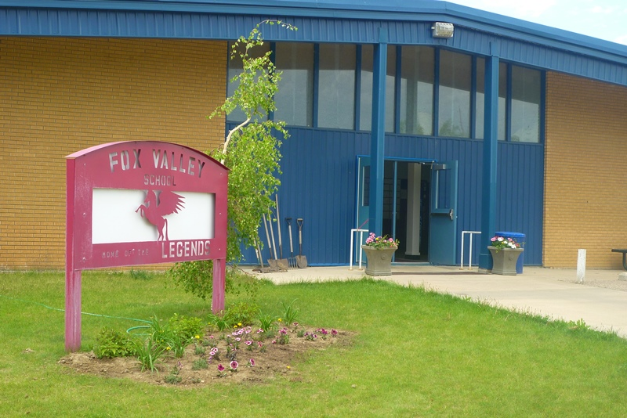
Fox Valley School Newsletter
January 1st, 2019

E-cigarettes and Vaping
A growing concern among educators and parents is the use of electronic cigarettes and vaping products by youth. We want to remind everyone that the use of tobacco, e-cigarettes and vaping in any form by students, employees or other people is not allowed on our school grounds or in our buildings. Students caught smoking, using or in possession of the prohibited products in or near the school will be disciplined according to policy.
E-cigarettes and vaping can be harmful to the user and to people exposed to the second hand e-cigarette smoke. Like regular cigarettes, e-cigarettes with nicotine are linked to a many harmful effects on children and youth—from addiction to disruptive effects on the developing brain. Please read the Canadian Paediatric Society’s recommendations on protecting children and youth from the dangers of e-cigarettes: https://www.caringforkids.cps.ca/handouts/e-cigarettes-a-danger-to-children-and-youth.

GRAD/PARENT MEETING
TUESDAY, JANUARY 15TH
6:30 PM IN THE SCHOOL LIBRARY
WOULD ASK THAT THE GRADUAND AND AT LEAST ONE PARENT BE ABLE TO ATTEND.

CONGRATULATIONS DOOR DECORATING WINNERS – GRADE 9 (MR. LEHMANN)!!!!!!

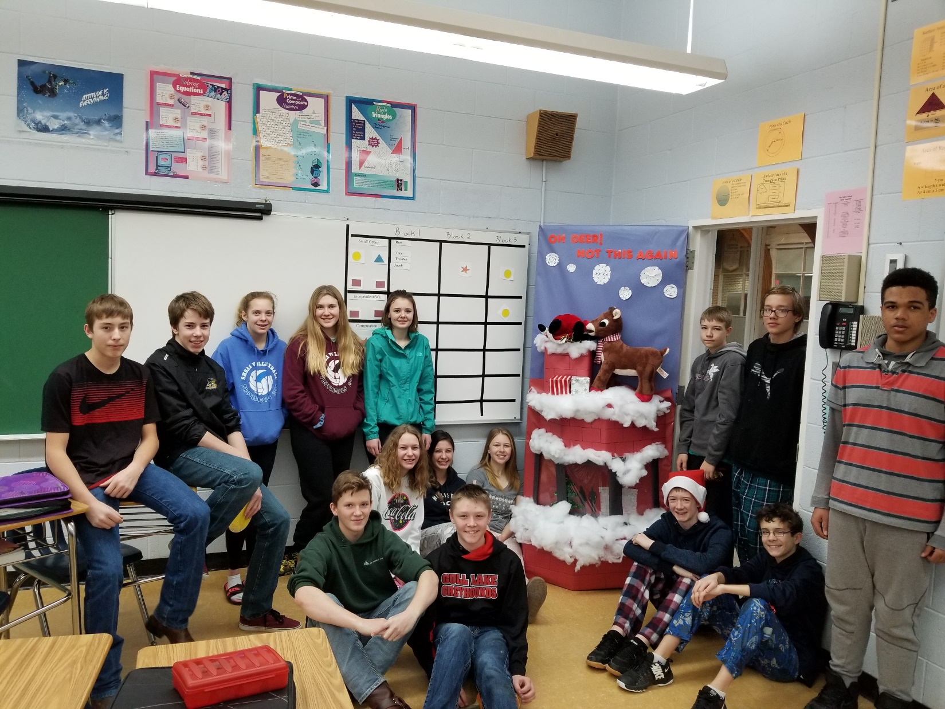

Mr. Lehmann’s classroom won the door decorating contest for the 4th consecutive year!!! We would like to thank all the other classes for participating in the annual door decorating contest. - Mr. Lehmann

WHAT’S HAPPENING IN THE CLASSROOM!!

Kindergarten and Grade 1
Kindergarten students are still working on letter and sound development. Grade 1 students continue to work on writing poetry. Students will be taking an imaginary trip to China in January!!! Stay tuned for more information!! - Mrs. Hudec

Grades 2 and 3
I'm excited to tell everyone that we will be having two Elder Helpers coming to visit in our classroom! We will be learning more about our next unit of study in Social Studies relating to treaties. – Mrs. Sunde

Grade 4 and 5
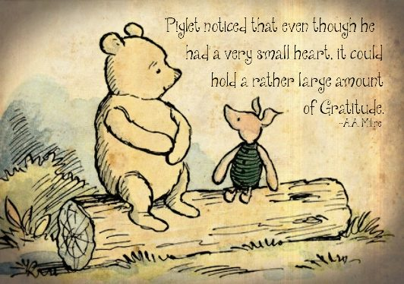
Everyday we write about something we are grateful for. Christmas is a time to be grateful for so many things we have in our lives. Here are the things we are feeling the most grateful for:
Nevaya - I am thankful for my dog Zoey because she is probably the fattest shitzu you would ever meet.
Tyler - I am thankful for my family because Jake plays with me, Shelby drives me places, Ryan helps me with work and Lacey lets my pick on her.
Dane - I am grateful for the people who built my house because if they did not come we would not have a house at the farm.
Lucas - I am grateful for my farm toys because I really like farming and living on a farm.
Hunter - I am thankful for my dog because I can play fetch and walk her every day.
Brock - I am thankful for my friends because my friends are very, very nice.
Trinity - I am thankful for Shelby because she helped me when I broke my arm.
Amara - I am thankful for my family because they love me and care about me and do so much for me.
Patience - I am thankful for my dog Lexie because she lays with me, plays with me, and loves me.
Nevan - I am thankful for my Dad because he helps me when I am hurt and gives me hugs every day.
Kelsey - I am grateful for my family because they love they me.
Kaiden - I am thankful for the snow because I can make lots of stuff and have a snowball fight with my brother.
Bridget - I am thankful for Christmas because Rachel, Rebecca and Bob come home and all my cousins come home.
Jaelyn - I am thankful for my mom's work because she is a nurse and we like to visit her when we are in Leader.

Wishing everyone a wonderful and blessed Christmas!! – Mrs. Hoffart

December has been a very busy month. The grade 4/5 class has finished up their Human Body Systems unit and will be starting the Simple Machines in January. Art class for both the 4/5 and 6/7 class has been filled with Christmas Concert practice. December was also filled with a special treat during Physical Education for grades 2 - 9 as we went skating at the arena. The students loved the change of scenery for gym and so did I!
-Miss Peers

Grade 6 and 7
In science 6/7 we have started a new unit on Mixtures and Solutions. We have been looking at matter and the different states that matter can be found in. Over the last couple of weeks we have been doing experiments looking at the differences between a pure substance and different kinds of mixtures (homogeneous and heterogeneous mixtures). The students have been having fun doing some experiments in the lab as well as finding the mass of different objects. – Mr. Lehmann

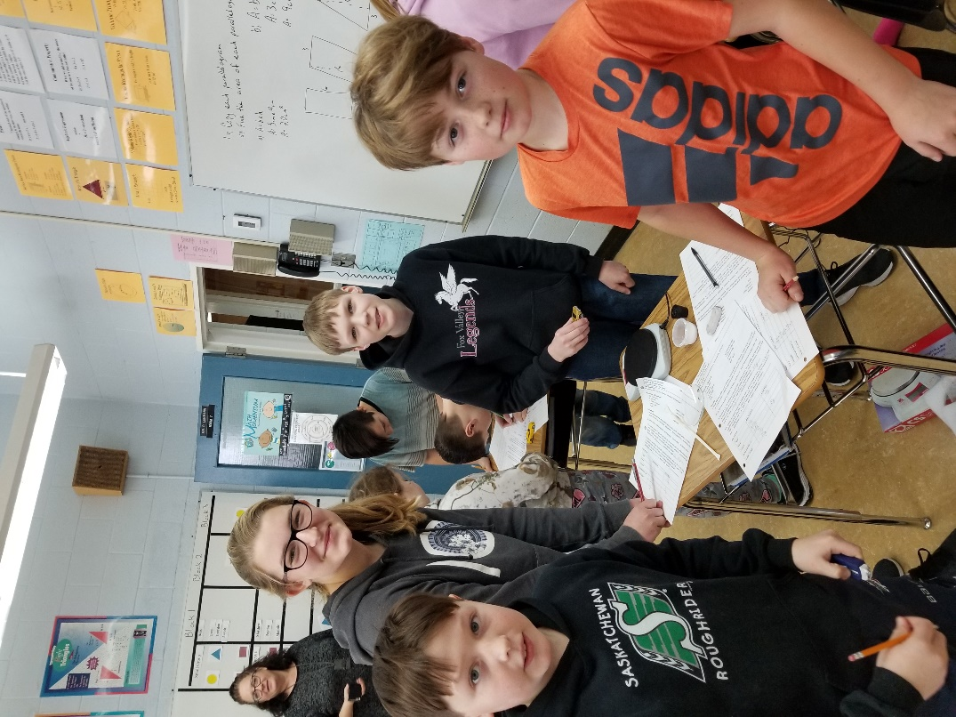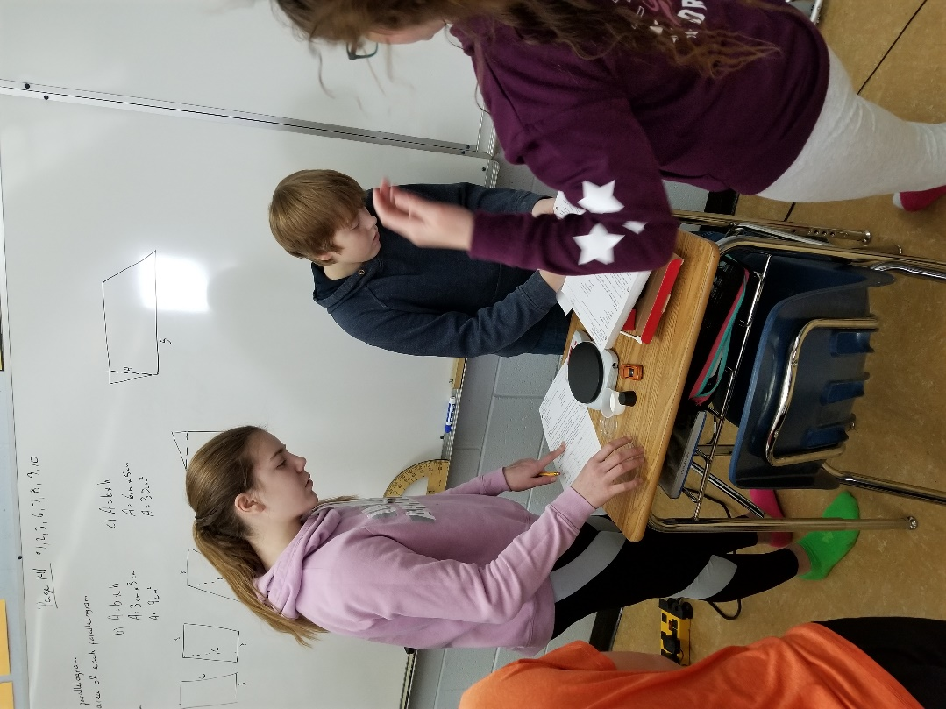

The Grade 6 ELA students got into the Christmas spirit and created their own Christmas stories. They then took these stories on the road and shared their ideas with the K/1 students. This is a wonderful opportunity to experience the joy their words can bring when they are shared with others. We will continue our journey as authors as we begin a new year. – Mrs. Kosolofski
Grades 8 and 9
ELA – we read narratives (Christian creation and Christmas; Greek – grade 8; Norse – grade 9), then wrote our own narrative. Mrs. Hellman read us the book, Miracle on 34th Street by Valentine Davies.
Science – grade 8’s learned about mass, volume, weight, and density, and will be learning about buoyancy next; grade 9’s learned about genetics, genetic engineering, and Punnett Squares, and will be learning about elements next.
Social – grade 8’s wrote a test on Canadian identity, and will next discover how an identity is created and what influences it; grade 9’s wrote a test on ancient Rome civilization, and will next learn about the Middle Ages.
In PAA, students made a Christmas craft; in health, they made a moral compass; in art, students used Christmas pictures to show their understanding of the elements and principles of art. - Mrs. Hellman

The grade 8/9 have been busy finishing up their respective math units on solving and graphing linear equations and solving for surface area for different objects before the Christmas break. Both classes took some time to use some measuring skills to decorate their homeroom door for the door decorating contest the SRC puts on. - Mr. Lehmann

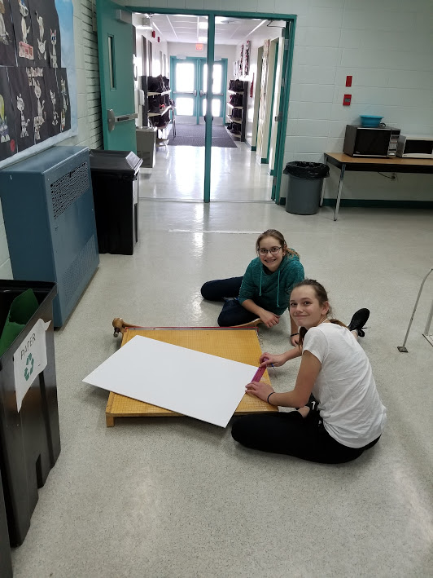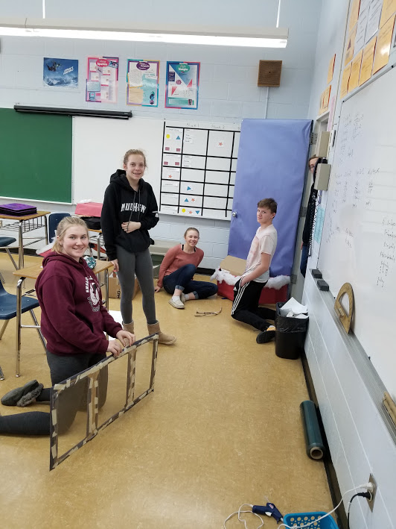

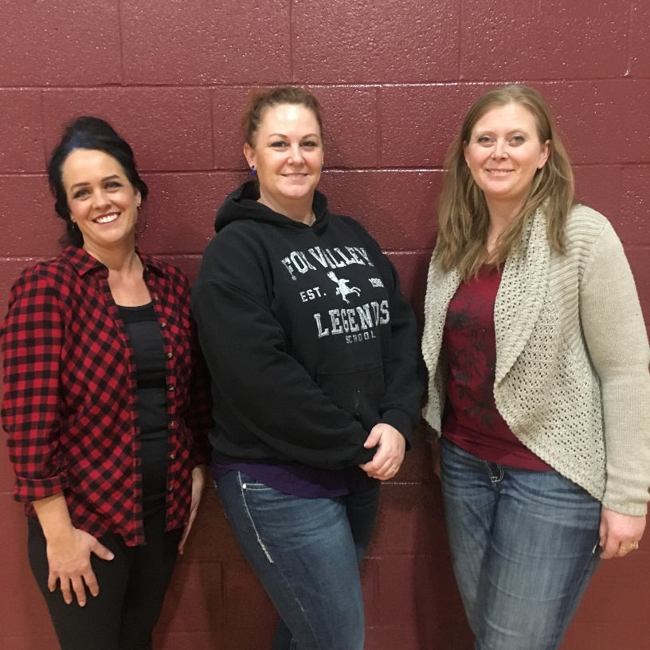
Thank you Lori Greenwald, Tara Jacksteit and Lori Wagner for helping with PAA 8/9

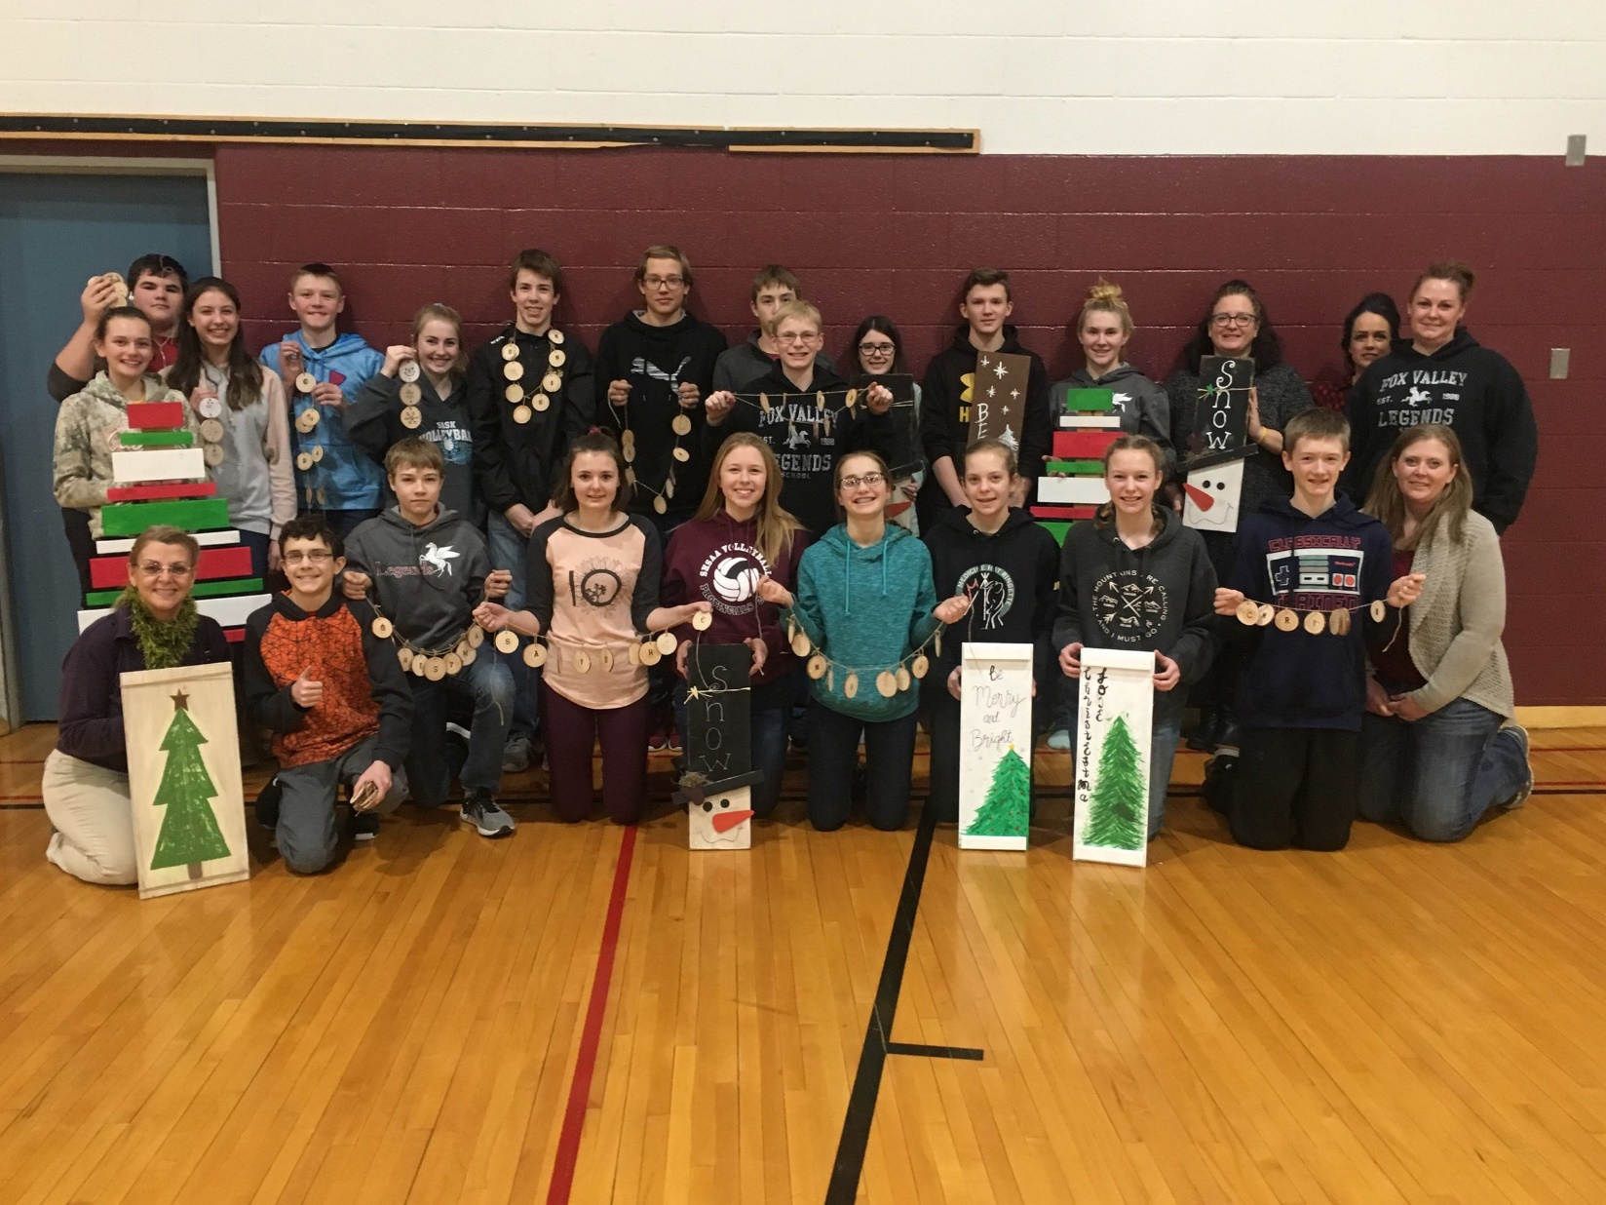

One of the Grade 10 projects this month was writing and performing a rant. Following is a random sample of some of their work.
I am here to tell you about a real issue, one that has been creating unrest and anger throughout the whole world since the dawn of time… Vegetables. And I don’t mean the good ones, like carrots and cucumbers. I mean the worst ones, the ones that are so vile I cringe when I swallow them. Spinach, broccoli, cauliflower, onions. Are we deer? Are we rabbits? We are humans. We eat meat. Steak, bacon, sausage. Those should be the things our parents feed us. We aren’t frickin herbivores. We don’t eat tree roots. We don’t eat palm branches. Why are we eating these plants? Grocery stores holding them should be knocked down. Fields growing vegetables should be burned. They are a disease in this world that must be eradicated!
Albertan drivers. They are just inconsiderate, mean, rude drivers that should go to jail. But they have to be a born true Albertan to be a jerk. I disgust them all grrrrrrrrrrrrr!! They say we Saskatchewan born drivers are bad and terrible, but go look in a bloody mirror you filthy animals. They are so cocky! “Look at me,” they must think. “I'm such a good driver that I changed lanes without freaking signaling!” Oh you know what really gets me? They think they rule the world by honking the horn at you or putting the middle figure up because you did the right thing. They think they’re good model citizens but they should be all shot with tranquilizer gun on sight for driving so horribly. Don't even get me started about their stupid redish-pink licence plate and their slogan on it. Do you even see any wild roses out on the side of the road? No you don't. I had an experience this summer when I was driving to Cypress Hills. When I entered Maple Creek, this Albertan driver was turning into the gas station but they never signaled once! It was very rude.
Why is musically/tik tok a thing all you do is make a video with movements to a song you might know or you don’t even know the song, the trend on musically are really stupid like the boy challenge as in you make yourself look like a boy, wall challenge as in you rub your elbow and put your hand a centimeter away from the wall, people can also make money off of musically/tik tok like if a muser goes live than you can send them gifts that cost real money and for one gift its a dollar and to get a drama queen which I the highest priced gift it is like twenty dollars for one and the musers usually ask for like three at a time and the muser can then take the money you had used to buy the drama queen that the other person had sent them and switch it for money which is a total waste of money, and if you have a lot of fans you are supposed to get a crown and give the chance to go to the musically/tik tok awards place if you have one million fans you get a crown but then some people that I have seen that have 4.8million fans don’t have a crown and not given the chance to go to the tik tok awards.
So you know that “Happiest time of the year” when everyone’s happy and laughing. When there's snow everywhere and it's cold and hockey's on all the time.
Yeah you know what i'm talking about… Christmas. So to all those people that like christmas can you explain why cuz I don't see anything joyful about it.
- It's always cold
- Everyone’s laughing and being happy and loud
- You have to go see your whole family
- The only music anyone ever listens to is Christmas music and that is absolutely trash anyone who makes Christmas music should grab all their music and throw it into the garbage can
- Driving anywhere is a trouble because the roads are so icy

My rant would be that I have to go to bed at 10 o'clock. My little sister always gets to stay up as long as I do even though I am three year older than her and when I was her age I had to go to bed long before ten. And of the people that I play video games with at night none of them have to go off when I get off. Another reason is that it doesn't affect my parents at all when I go to bed. My parents even know that I stay up on my phone when I am supposed to go to sleep so why can’t I just stay up and play video games. Also I know I am a responsible young adult so I should be allowed to choose when I go to sleep. Another thing is I get my homework done almost always when it is due. So I think that I should be able to stay up longer.
I’m a rancher. People say all I do is ride the horse and fix the fence. Where the hell do they think beef comes from? Oh yah from the local store. I’m just a dirty cowboy, eh. Ol’ son I wanna open a new window to your downtown skyscraper, I’m the guy who makes your food. You sit on that couch’n the air conditioned office right, and you complain about the hard work you do. Oh yah that pencil weighs lots eh. Any rancher knows what I’m talking bout, people forgetting and stepping on our hats right? I’m tired of this crap, I’d like to see how many people could put up a mile of fence, pull a calf in -40 snow storms, or haul bales in a truck with no brakes or fan. Oh no because those pretty little hands of yours shouldn't get dirty. Well ol’ son it’s about time you pull your head out of your rears and notice who really does the hard work in the world.
March 29, 2017. That date might not mean much to you but it sure does to a lot of other people. March 29, 2017 is the day that Club Penguin shut down. Disney made the huge mistake of ending childhood joy. Millions of children played this game and they shut it down without even considering how we would feel. Our penguins died that day, all of our puffles too. We worked so hard to make our homes beautiful and make money. We devoted our afternoons and evenings to that game and Disney just took it away. Then they tried to replace Club Penguin with Club Penguin Island. Um, same thing much? The new game is only for mobile devices, which is absolutely ridiculous! What if a nine year old wants to play but they don’t have a mobile device? It’s an outrage! I am especially connected to this issue because I played Club Penguin as a young child. When I heard that they were going to shut down Club Penguin, it hurt me deep inside. I knew that my beautiful purple penguin would never get to walk its puffles ever again. Never get to go clothes shopping with his hard earned money. On March 29, 2017, a part of me died with that game. And so, I vote to abolish Club Penguin Island. I make the motion to bring our penguins and puffles back to life. I declare Club Penguin REBORN!
Don’t you love it when you’re walking through Walmart to get your favourite dandruff shampoo, that's the only one that seems to ever work, only to find a barren wasteland when you arrive at the correct isle, only finding an “On Sale” sign remaining? That’s what we call shopping anytime between October and late December. Big companies and stores love putting things on sale during this new era dubbed the “Christmas season”. What once was a holiday to celebrate joy, love, and the coming of Christ has turned into a huge commercial commotion worthy of Disney themselves. People maul each other over getting the Barbie Dreamhouse their 5 year old daughter wants, or that new set of dentures that’s half off for Grandpa. Then you have people stealing things from each other’s carts whenever the other person sees the new Taylor Swift album. Remember what I said earlier? About joy and love? What about this reminds you of these 2 qualities? Unless you’re a ruthless politician, probably none of it. But the big guys at TV channels and stores of all kinds eat it up like supermodels do the latest diet. But I’m not one to go with the flow. Sure, I enjoy the discounts too, but this is just too much. Some people even wait until Boxing Day to buy their presents, when they go on sale. “Mommy, mommy, what did I get for Christmas?” “A couple of coupons for McDonald’s, we’re getting your presents tomorrow from a crowded store that probably won’t have that amazing new Barbie with the pooping dog you want!” I’m sure that's what every kid wants to hear on Christmas morning. The industry is controlling people. It has more power than the government. Does Trudeau walk up to your door and make your family all play Twister? I doubt, but then again you never know. However, the industry has people filled with anger and aggression at each-other’s throats in an all out Battle Royale over what? Cheap chocolate to get those relatives you might as well be legally obliged to get presents? So, I ask of you, rebel against the industry. Just because you don’t get every discount doesn’t mean it’s the end of the world as we know it.
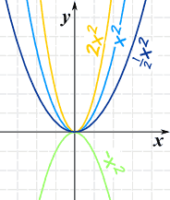
-Mr. Glass
Grade 11
In December, the Grade 11 Foundation of Math 20 class is spending time learning how to graph quadratic equations. They are working through manual techniques but are also using technology in the form of graphing calculators to help them graph quadratic functions and solve quadratic equations. – Mr. Schmitz

Health Science 20
The Doctors have studied the circulatory system and can trace the path of blood through the heart!!! After looking at blood samples from our four patients Will Smith has officially been diagnosed with sickle cell anemia - those sickled red blood cells are going to be giving him some problems!!! Ariana Grande has a low red blood cell count which can further our hypothesis that she may be pregnant!!! Justin Bieber continues to give us the impression that he may have HIV with that low white blood cell count. A further look at the respiratory system and immune system may give us some more insight into what is ailing a few of our patients. Stay tuned!!! – Mrs. Lehmann

January At A Glance
January 7 – Back to School!!
January 11 – Noon Lunch – Soup & a bun & juice box $5
January 15 – GRAD/Parent Meeting @ 6:30 p.m. in the Library
January 15 – SCC Meeting @ 7:30 p.m.
January 18 – Noon Lunch – Pizza Buns and a juice box $3 or 2 for $5
January 23 – January 28 - Exams
January 29 – Turn Around Day – NO SCHOOL
January 30 – Semester II Begins

JANUARY 2019 EXAM SCHEDULE
 | Grade 6/7 | Grade 8 | Grade 9 | Grade 10 | Grade11 | Grade 12
Wednesday, Jan 23 Day 4 |  |  |  | Math 10 | ELA 20 | ** ELA A30
Thursday, Jan 24  Day 5 | Math 7 only  Pd 1 |  |  | History 10 | Environmental Science 20
Friday, Jan 25  Day 6 | ELA 6 pds 1/2 | Math 8 pd 2 | Math 9 pd 2 | Science 10 | Health Science 20
 | ELA 7 pd 3
Monday, Jan 28  Day 1 |  | ELA 8 | ELA 9 | ELA A10 | Foundations 20 | ** Pre-Cal 30
**Departmental Exam

Open campus during Exams
Grades 10, 11 and 12 Will have open campus from Wednesday, January 23rd through Monday, January 28th
Grades 9 and down Will NOT have open campus but instead classes continue as scheduled on the timetable.
PLEASE NOTE THAT THE TIMETABLE WILL CHANGE FOR ALL STUDENTS IN GRADES 6 AND UP STARTING WEDNESDAY, JANUARY 30TH.

